Phrase 1:
1.Mark Placing Handler check the Contract Fulfilment Case
Tool : Monitor mark placing result.js,
Incompleted button,
Click | GPS Case Lifecycle Management flow
Description :
- Update the values of the "Mark Placing Handler" in js when the user directly modifies the values of the Mark Placing Result
- Incomplete button will pop up a canvas window. If user confirm the operation, it will trigger “Click | GPS Case Lifecycle Management” flow to update to Update the values of the "Mark Placing Handler" 、“Mark placing result” and “Case status”.

2.Automated Case and Task Creation from SharePoint Folders
Tool : Schedule | When 10 am/3 pm to get Contract Fulfilment Case from SharePoint flow，
Subflow | Get Contract Fulfilment Case from SharePoint flow，
Subflow | Create Contract Fulfilment Case flow (Excel Srcipt : Get Placing Instruction Form Sheet、Get Value from Placing Instruction Form)，
Subflow | Create Contract Fulfilment Task flow，
Subflow | Set the property of SharePoint folder flow
Description :
- The schedule flow is triggered at 10 a.m. and 3 p.m. every day, and this flow will call the Subflow | Get Contract Fulfilment Case from SharePoint flow
- In Subflow | Get Contract Fulfilment Case from SharePoint flow, this flow will find the target file layer by layer in the SharePoint folder. After finding the file, a copy of the file will be made to one drive, and then Subflow | Create Contract Fulfilment Case flow will be triggered. If the target file is not found in the case folder, a not ready case will be generated. In addition, each time it is triggered, the files previously copied to one drive will be deleted.
- In Subflow | Create Contract Fulfilment Case flow, this flow utilizes the transmitted parameters to first obtain the tab of the target file. If it matches the configuration of the date configuration, the data of the current file will be obtained. Next, the corresponding case will be generated based on the obtained data content. If the New case is successfully generated, the Subflow | Create Contract Fulfilment Task flow will be called to generate a task. If this flow reports an error, it will be captured in the flow of the previous layer and a not ready case will be generated.
- In Subflow | Create Contract Fulfilment Task flow, this flow generates tasks based on the parameters passed over.
- After generating the case, some information of the case and some information of the file will be passed to Subflow | Set the property of SharePoint folder flow to modify the values of the case id and case status of the case folder on SharePoint

3. Automated SharePoint Folder Status Sync and Notification
Tool : Subflow | Set the property of SharePoint folder flow
Description : This flow will modify the case id and case status on SharePoint based on the parameters passed over

4.Automated Task Creation for Not Ready Case
Tool : Schedule | When 10 am/3 pm to get Contract Fulfilment Case from SharePoint flow，
Subflow | Check Not Ready Case from SharePoint flow,
Subflow | Create Contract Fulfilment Case flow (Excel Srcipt : Get Placing Instruction Form Sheet、Get Value from Placing Instruction Form)，
Subflow | Create Contract Fulfilment Task flow，
Subflow | Set the property of SharePoint folder flow
Description :
- The schedule flow is triggered at 10 a.m. and 3 p.m. every day, and this flow will also call the Subflow | Check Not Ready Case from SharePoint flow
- In Subflow | Check Not Ready Case from SharePoint flow, this flow will directly retrieve the not ready case in the database, and then go to SharePoint to directly find the corresponding file using the case id. After finding the file, the Subflow | Create Contract Fulfilment Case flow will be triggered to detect whether the content of this file already meets the conditions of the new case. If it meets the requirements, supplement the field content and modify it to the "new" status. At the same time, trigger the Subflow | Create Contract Fulfilment Task flow to generate a task and trigger the Subflow | Set the property of SharePoint folder flow to update the value of the "case status" on SharePoint. If it does not meet the requirements, continue to maintain it.

5. Automated Case and Task Generation from Tagged Member Movement Emails
Tool : Subflow | Case and Task Generation from Tagged Member Movement Emails flow,
Subflow | Get Member Movement Tasks from Excel flow（Excel Script : Get Tasks from Straight-Through Manual update report，Get Tasks from Bupa Request for information Change Form）
Description ：
- In Subflow | Get Member Movement Tasks from Excel flow , This flow will accept the parameters transmitted over, obtain the information of excel to determine if the file is normal. If it is not normal, it will return the information of the erroneous file to Subflow | Case and Task Generation from Tagged Member Movement Emails flow. If it is normal, it will use the name of excel to determine which excel script to use to obtain the task content in excel Then return to Subflow | Case and Task Generation from Tagged Member Movement Emails flow.
- In Subflow | Case and Task Generation from Tagged Member Movement Emails flow, If the Excel branch is taken, the information of the tasks in excel will be obtained, and then the obtained data will be processed. If there is any information that does not conform to the rules, it will be separated and placed in the daily summary email. At the same time, emails with a null contract type will also be separated and placed in the daily summary emails.( This has not yet been tested and applied to SIT, UAT and Prod)

Phrase 2:
- Sales Lead Case Handling: operations
Tool : Case status dropdown button /Submit button
Sales Lead Buttons.js
Sales Lead Form.js
Click | Sales Lead Lifecycle Management flow
Subflow | Sales Lead history generation flow
Sales Lead Comment Popup page
Automated | Create Sales Lead History when create manually flow
Description :
- Case status dropdown button is pending confirmation. Among them, the control of showing and hiding based on the case sub type has been done. If confirmed, only one line of comment in Sales Lead Buttons.js needs to be removed.
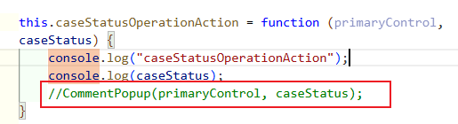
- 2. The submit button is the current method. After the user changes the status and clicks "Submit", the current form is saved. Once confirmed, Click | Sales Lead Lifecycle Management flow will be triggered to update the case status, and then Subflow | Sales Lead history generation flow will be called to add a new sales lead history record.
- Sales Lead Form.js here uses the caseStatusOptionSet method to show or hide the option of case status based on the case sub type
- Each newly created sales lead will trigger Automated | Create Sales Lead History when create manually flow to create a new draft history record

- Manual Versioning of Placing Form with Explicit "Save placing form copy" Action
Tool : Save placing form copy button,
Sales Lead Buttons.js
Sales Lead Form.js
Placing Form Version Onload.js
Card Type Form.js
Click | Save Placing Form Copy flow
Automated | Create First Placing Form Version flow
Save placing form copy popup page
Description ：
1. Each time a new sales lead is created, Automated | Create First Placing Form Version flow will create a new placing form version record for it. And the function of Sales Lead form.js is that when this placing form tab is clicked, if the form is not loaded, it will keep refreshing until it appears
2. Click the Save placing form copy button, and a pop-up window will appear. The note you wrote corresponds to the note field in the table. Then, after confirming, call Click | Save Placing Form Copy flow to create a new placing form version record and create the relevant card type records and update the version of the current record
3. If it is a history record, Placing Form Version Onload.js and Card Type Form.js will lock both the placing form and the card type completely and prevent them from being edited

- Table
  - BUPA Activity History
Commonly used columns : Action, Comment, Record start time, Record end time, Record operator, Record status,Type
View:
BUPA Sales Lead History
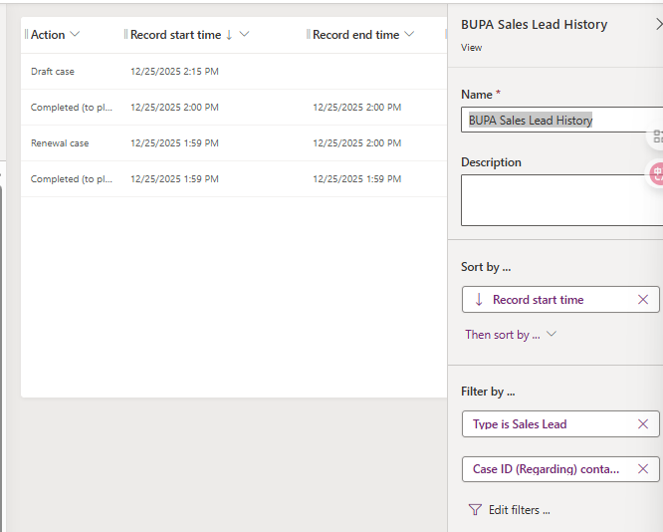
BUPA QS proposal id history
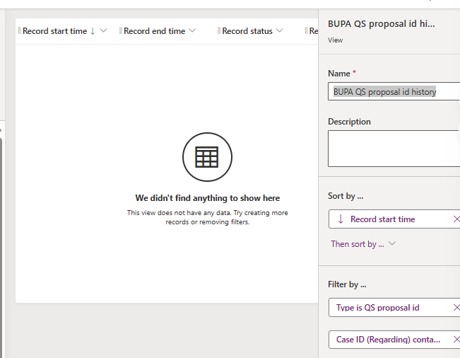
BUPA QS Version History
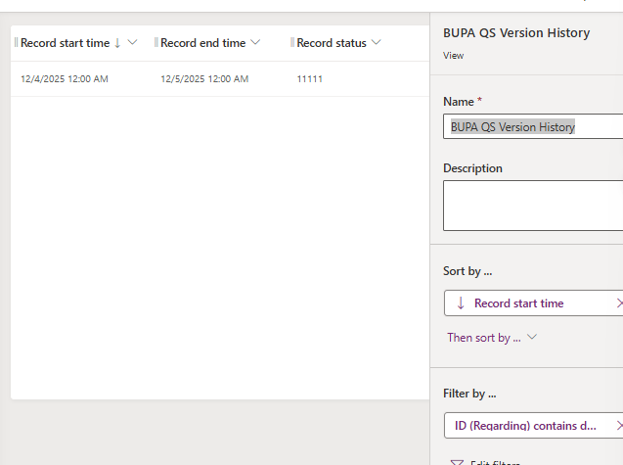
  - GEB client list—virtual table
Env Var: Sharepoint Site Environment Variable - GEBclientlist
  - Insurer—virtual table
Env Var : Sharepoint Site Environment Variable – Insurers
1. Mark Placing 结果监控与状态管理
使用工具： Power Apps (JavaScript), Power Automate Flow
工作内容： 开发前端字段监听逻辑与自动化流程编排
实现功能：
- 通过Monitor mark placing result.js实现前端字段变更监听，当用户直接修改"Mark Placing Result"时自动更新"Mark Placing Handler"字段
- 设计Incomplete按钮交互逻辑，通过画布应用弹出确认窗口，触发"GPS Case Lifecycle Management"flow批量更新Handler、Result及Case Status字段
2. SharePoint文件夹驱动的Case与Task自动创建
使用工具： Power Automate (Scheduled Flow + 5个Subflow), SharePoint Online, OneDrive, Excel Office Scripts
工作内容： 构建定时自动化流程体系，实现文档到业务数据的自动转换
实现功能：
- 配置定时触发器（每日10:00/15:00），自动扫描SharePoint多层文件夹结构定位目标文件
- 通过Excel Scripts（Get Placing Instruction Form Sheet等）解析Excel内容，自动创建Contract Fulfilment Case记录
- 建立文件生命周期管理：临时复制到OneDrive处理，完成后自动清理，避免重复处理
- 异常处理机制：未找到目标文件时自动生成"Not Ready"状态Case，保障业务连续性
3. SharePoint文件夹状态双向同步
使用工具： Power Automate Subflow, SharePoint REST API
工作内容： 打通Dataverse与SharePoint的元数据同步通道
实现功能： 基于Case生成/更新事件，自动回写Case ID和Case Status至SharePoint文件夹自定义属性，实现文档库与业务状态实时同步
4. Not Ready Case自动补偿机制
使用工具： Power Automate (Scheduled Flow + Subflow), Dataverse
工作内容： 设计补偿事务流程，处理历史遗留数据
实现功能：
- 定时扫描数据库中"Not Ready"状态记录，反向追溯SharePoint源文件
- 动态校验文件内容完整性，满足条件时自动补充字段并状态迁移（Not Ready → New）
- 联动Task创建与SharePoint属性更新，实现闭环处理
5. 邮件标记的Member Movement自动化处理
使用工具： Power Automate (Subflow), Excel Office Scripts, Exchange Online
工作内容： 构建邮件驱动的ETL流程，实现数据清洗与异常隔离
实现功能：
- 解析标记邮件附件Excel，通过脚本自动提取Straight-Through Manual update report和Bupa Request for information Change Form中的任务数据
- 数据规则校验引擎：自动识别异常数据与空合同类型记录，隔离至日报邮件，确保主流程数据质量
- 自动生成Member Movement Case与关联Task

Phase 2: Sales Lead Management System (销售线索管理系统)
1. Sales Lead全生命周期管理
使用工具： Power Apps (JavaScript: Sales Lead Buttons.js, Sales Lead Form.js), Power Automate, Dataverse
工作内容： 前端交互逻辑开发与流程自动化编排
实现功能：
- 动态UI控制：基于Case Sub Type实现Case Status下拉选项的条件渲染（显示/隐藏逻辑）
- 状态机驱动：Submit按钮触发"Sales Lead Lifecycle Management"flow，实现状态流转与数据持久化
- 审计追踪：通过Subflow | Sales Lead history generation flow自动生成历史记录，记录状态变更轨迹
- 初始化机制：新建记录时自动触发flow创建Draft状态历史记录，确保数据完整性
2. Placing Form版本控制与手动存档
使用工具： Power Apps (JavaScript: Placing Form Version Onload.js, Card Type Form.js), Power Automate, Dataverse
工作内容： 构建文档版本管理系统，实现显式版本控制
实现功能：
- 自动版本初始化：新建Sales Lead时通过Create First Placing Form Versionflow自动生成首个版本记录
- 手动版本快照：开发"Save placing form copy"功能，支持用户添加版本注释，自动复制Placing Form与关联Card Type记录
- 历史锁定机制：历史版本自动启用只读模式（通过Onload脚本锁定控件），防止误编辑，确保版本不可篡改
3. Dataverse数据建模与虚拟表集成
使用工具： Dataverse, Power Apps, SharePoint (Virtual Tables)
工作内容： 数据架构设计与外部系统集成
实现功能：
- 设计BUPA Activity History实体，配置Action、Comment、Timeframe等字段，建立Sales Lead History、QS Proposal ID History、QS Version History多视图
- 构建Virtual Table架构：通过Environment Variables配置SharePoint连接，集成GEB Client List与Insurer外部数据源，实现无缝数据引用

Option 1: 侧重Power Platform全栈能力
Power Platform Developer | 业务流程自动化与系统集成
基于Microsoft Power Platform（Power Apps, Power Automate）为企业级保险业务设计并交付端到端自动化解决方案：
• SharePoint-Dataverse集成开发：构建定时自动化流程（每日2批次），实现SharePoint文档库与Dataverse的双向数据同步，自动解析Excel指令单生成200+合同履约Case，消除人工录入环节，提升数据处理效率100%
• 低代码应用开发：使用Power Apps + JavaScript开发Sales Lead管理系统，实现动态表单逻辑、状态机驱动的工作流及版本控制机制，支持Placing Form多版本存档与审计追踪
• 复杂业务逻辑编排：设计5层Subflow架构处理异常补偿机制（Not Ready Case自动检测与修复），集成Exchange Online实现邮件触发式任务生成，建立数据质量校验规则自动隔离异常数据至管理报表
Option 2: 侧重业务价值与量化成果
Business Automation Specialist | 保险行业数字化解决方案
主导Bupa保险核心业务系统的自动化改造，通过Power Platform技术栈实现文档密集型业务流程的数字化转型：
• 智能文档处理流水线：开发SharePoint Online与OneDrive联动的自动化工作流，定时抓取投保指令文件，通过Excel Scripts解析数据并自动创建履约Case与关联Task，实现从文档接收到任务分配的全链路自动化
• 数据一致性保障机制：构建双向同步引擎，确保SharePoint文件夹元数据与Dataverse Case状态实时同步（Case ID/Status），开发补偿事务流程处理历史遗留Not Ready Case，数据闭环率达到100%
• 企业级应用功能开发：实现Sales Lead全生命周期管理（状态机、审计日志、版本控制），设计Virtual Table集成外部SharePoint数据源（Insurer/GEB Client List），构建统一的客户数据视图
Option 3: 简洁版（适用于简历 bullet points）
• 使用 Power Automate 开发定时调度流程（Daily 10AM/3PM），自动扫描SharePoint目录解析Excel指令单，通过Excel Office Scripts提取数据并自动生成Dataverse Case/Task记录，替代人工数据处理流程
• 设计异常处理与补偿机制：开发Subflow自动检测"Not Ready"状态Case，反向追溯SharePoint源文件补充数据，实现业务流程闭环与数据质量自动修复
• 基于Power Apps + JavaScript开发Sales Lead管理系统，实现动态表单渲染、状态流转控制及Placing Form版本管理（自动存档+历史锁定），满足合规审计要求
• 构建Dataverse Virtual Table架构，通过Environment Variable集成SharePoint外部数据源（Insurer/Client List），实现跨系统数据统一引用与实时查询

简历可用的专业表述（产品经理方向）
Option 1: 侧重产品全生命周期管理（推荐）
Bupa Business Automation Product Manager | 保险业务流程数字化
负责Bupa保险核心业务系统的产品规划与交付，主导从需求分析到上线的全生命周期管理，通过低代码平台实现业务流程自动化改造：
• 端到端产品设计：独立负责Contract Fulfilment履约系统的产品规划，设计SharePoint文档驱动的Case自动创建机制，将人工录入流程转化为自动化处理，每日自动处理200+投保指令，数据录入效率提升100%
• 异常闭环机制设计：针对源文件缺失场景设计"Not Ready Case"补偿机制，定义自动检测→追溯→修复的完整产品逻辑，实现业务流程100%闭环，零数据遗漏
• Sales Lead管理系统重构：主导销售线索全生命周期管理产品设计，定义状态机流转规则、版本控制策略及审计追踪机制，满足合规要求的同时提升销售团队操作效率
• 跨系统集成规划：设计Dataverse与SharePoint、Exchange Online的系统集成方案，通过Virtual Table架构打通外部数据源，构建统一的客户数据视图，消除信息孤岛
版本控制与合规产品：针对保险表单频繁变更场景，设计Placing Form显式版本管理功能，定义自动存档、手动快照、历史锁定三层机制，满足审计合规要求
• 跨团队协作：作为业务-技术桥梁，协调低代码开发团队完成Power Platform方案落地，2个月交付Phase 1，系统上线后每日自动化处理200+Case，零人工干预

简洁版（简历Bullet Points，快速筛选场景）
• 产品规划：主导保险履约系统从0到1设计，定义SharePoint文档→Case自动生成的核心流程，覆盖投保指令处理、异常补偿、邮件触发任务三大场景，替代原人工录入流程
• 需求分析：深度访谈业务团队，抽象Sales Lead管理痛点，输出状态机流转、版本控制、审计追踪等产品PRD，确保合规前提下提升销售操作效率
• 跨团队协作：作为业务-技术桥梁，协调低代码开发团队完成Power Platform方案落地，2个月交付Phase 1，系统上线后每日自动化处理200+Case，零人工干预
• 数据治理：设计数据质量校验规则与异常隔离机制，自动识别错误投保数据并推送日报，保障核心业务流程数据准确率99%+

